Response to Reviewers
We extend our thanks to the Editor for overseeing this second revision and for acknowledging the importance of our work. We also appreciate the Reviewers' thoughtful and constructive comments. Each suggestion has been carefully integrated, with all new updates highlighted in red within the text. These refinements have further solidified our core arguments, sharpened the narrative clarity, and polished the overall quality of the study.

Reviewer 1
Comments:
Thank you for giving me the chance to read your manuscript and that you carefully adressed the comments. Overall, the manuscript is close to publishabel form - from my point ov view. My suggestions may halep you in terms of calrity, robustness and hopefully impact.
Thank you for taking the time to review the submission, your comments are clear and will clearly improve the quality of the submission.
Comment 1:
1. Originality: Does the paper contain new and significant information adequate to justify publication?: I think the manuscript offers a meaningful contribution to geodemogrpahic and retail resarch. You integrated the comments on introduction, LR and discussion. It is now more clearly positioned against demographically classifications and explains how it integrates existing frameworks. The revision has substantially improved. While the theoretical positioning is clearer, the manuscript could benefit from one short, explicit statement (perhaps in the Conclusion) summarising in 2–3 sentences the core theoretical advancement in comparison to OAC, Mosaic, and related systems. Some contribution statements seem repetitive.
We appreciate the Reviewer’s suggestion to further sharpen our theoretical positioning. We have added an explicit statement to the Conclusion (p.11 lines 36-42) that distinguishes our classification from OAC and Mosaic. This statement clarifies that our core advancement lies in treating digital and spatial accessibility as co-determining drivers of behaviour, rather than secondary socioeconomic outcomes, within a transparent and open framework. We have also audited the manuscript to remove repetitive contribution statements as suggested in the introduction (p.2 lines 38-40), and conclusion (p.11 lines 36-38), where it has been replaced by the statement suggested by the reviewer.
Comment 2:
2. Relationship to Literature: Does the paper demonstrate an adequate understanding of the relevant literature in the field and cite an appropriate range of literature sources? Is any significant work ignored?: The LR demonstrates strong coverage and requested improvements have been implemented. However, the review still can improve in critically camparison. I tink this helps to sharpen arguments.
We thank the Reviewer for this insightful suggestion. We agree that moving beyond a descriptive summary toward a more critical evaluation significantly strengthens the theoretical justification for our study. In this second revision, we have added text to explicitly contrast and synthesise existing research. We have reframed the discussion of demographics and accessibility to highlight the tensions between structural socioeconomic drivers (e.g., income) and evolving lifestyle priorities (e.g., life stage) (p.3 lines 21-23 & 27-30) and how spatial context acts as a behavioural modifier (p.3 lines 35-39). We have added a focused discussion on the critical trade-offs between "open" and "proprietary" geodemographic systems. We position our work as a link that combines the transparency of open models (like OAC) with the behavioural depth typically reserved for "black box" commercial systems (like Mosaic) (p.5 lines 13-19). These changes ensure the Literature Review now serves as a more critical foundation for our multidimensional framework.
3. Methodology: Is the paper's argument built on an appropriate base of theory, concepts, or other ideas? Has the research or equivalent intellectual work on which the paper is based been well designed? Are the methods employed appropriate?: The methodological design is well described and transparently structured. However, while reliability diagnostics are now described, the revision does not appear to introduce deeper robustness testing (e.g., alternative clustering comparisons or stability analysis). The response strengthens justification rather than fundamentally extending the analysis.
We appreciate the Reviewer’s point regarding robustness testing. To address this, we have added specific detail to the clustering section (p.7 lines 22-38) regarding our selection process. We have clarified that k-means was chosen following a comparative evaluation where it outperformed alternative methods. We have developed the stability testing described in the Methodology section (p.7 lines 27-29) where we discuss the use of a clustergram and elbow plots to determine optimum values of k. We feel the resulting section is strong in its justification of the selection of k = 4, and the justification for using k-means clustering.
4. Results: Are results presented clearly and analysed appropriately? Do the conclusions adequately tie together the other elements of the paper?: The results are clearly structured around four main clusters and nine sub-clusters. he connection between empirical findings and the conceptual framework is clearer and more convincing. I suggest to include a short table that summarize the key findings --> transparency.

We appreciate the Reviewer’s suggestion to improve the transparency of our results. In response, we have expanded the existing summary table (Table 1, p.8) to include a dedicated "Key Findings" column. This updated table now provides a concise, high-level synthesis of the four primary clusters and nine subclusters, explicitly linking each group to the core behavioural and spatial characteristics derived from our analysis. We believe this enhanced table provides the requested clarity and transparency while effectively bridging the conceptual framework with our empirical results.
Before: 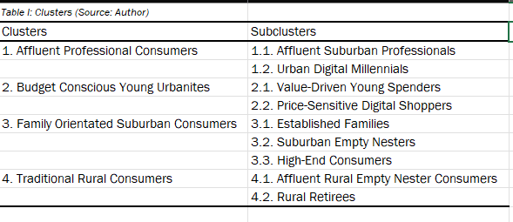
After:
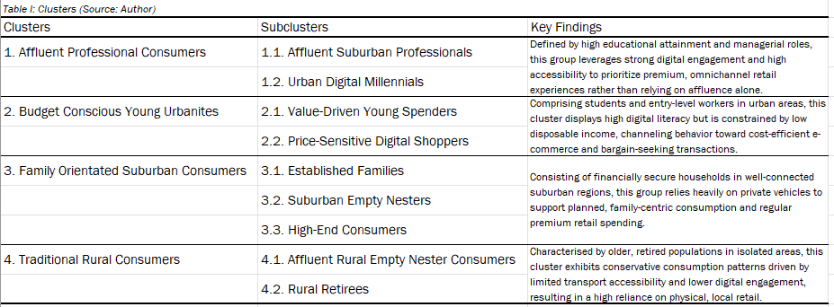
5. Implications for research, practice and/or society: Does the paper identify clearly any implications for research, practice and/or society? Does the paper bridge the gap between theory and practice? How can the research be used in practice (economic and commercial impact), in teaching, to influence public policy, in research (contributing to the body of knowledge)? What is the impact upon society (influencing public attitudes, affecting quality of life)? Are these implications consistent with the findings and conclusions of the paper?: One of the strongest improvements in the revision concerns implications. The bridge between theory and practice is now well articulated. The practical relevance for both commercial and public-sector stakeholders is convincingly demonstrated.
We are very pleased that the Reviewer found the improvements to the practical and theoretical implications compelling. We agree that bridging the gap between academic geodemographic research and its application for stakeholders is a primary goal of this study. In this second revision, we have ensured that these implications remain central to the narrative, particularly within the newly added summary statements in the Conclusion, to further solidify the connection between our empirical findings and their real-world utility (p.11 lines 36-42). Also, we have removed repetitions of some contribution claims and tightened areas for coherence as suggested in other comments.
6. Quality of Communication: Does the paper clearly express its case, measured against the technical language of the field and the expected knowledge of the journal's readership? Has attention been paid to the clarity of expression and readability, such as sentence structure, jargon use, acronyms, etc.: The manuscript is well structured, clearly written, and technically appropriate for the journal readership. The revision improves clarity in several sections and enhances figure readability.
Some minor repetition of contribution claims remains, and a few passages could still be tightened stylistically.
We are grateful for the Reviewer’s overall positive assessment of the manuscript’s structure, clarity, and technical appropriateness. To address the remaining concerns regarding repetition and stylistic flow, we have conducted a thorough check of the text, ensuring the paper is tighter and reads well. Specifically, we have removed several overlapping contribution and purpose statements in the introduction and conclusion to ensure the study’s value is articulated well but without unnecessary redundancy. These tightening measures have improved the narrative, creating a more direct link between our theoretical framework and the empirical findings while allowing the advancements of our study to be clear.

Reviewer 2
Before responding to the individual comments, we wish to thank the Reviewer for their continued time and dedication to our manuscript. We appreciate the feedback provided during this second round of review.

Comments:
This paper makes a valuable contribution to geodemographic research by developing an open, multidimensional classification of consumer behaviour at a fine spatial scale. Its integration of behavioural, digital, and spatial factors represents a meaningful step forward from traditional models.
However, the study is constrained by:
Data limitations and reliance on microsimulation
Simplified clustering methodology
Limited validation and static design
Overall, it is a strong and practically relevant study, but future work should focus on:
Dynamic modelling approaches
More robust validation strategies
Exploration of alternative clustering methods
We appreciate the reviewer’s positive assessment of our framework and its contribution to geodemographic research. We acknowledge the constraints regarding the static design and clustering methodology; consequently, we have strengthened the conclusion to explicitly address these limitations. Specifically, we have added a discussion on the cross-sectional nature of the study and outlined how future research can transition toward dynamic modelling to capture behavioural evolution. Furthermore, we have clarified our choice of k-means while acknowledging that future iterations will explore alternative clustering techniques and more robust validation strategies to further refine the classification’s spatial and temporal accuracy. The changes are detailed below with page and line numbers.
Additional Questions:
Comment 1:
1. Originality: Does the paper contain new and significant information adequate to justify publication?: This paper presents a novel geodemographic classification of consumer behaviour across England and Wales, integrating survey data, census variables, and accessibility metrics at a fine spatial scale (LSOA level). The key contribution lies in developing an open, multidimensional classification framework that moves beyond traditional socioeconomic segmentation by incorporating digital engagement and spatial accessibility alongside behavioural variables.
We appreciate the Reviewer’s recognition of the study’s novelty. We are pleased that the integration of digital engagement and spatial accessibility alongside behavioural data was identified as a key contribution that moves beyond traditional socioeconomic models.
Comment 2
2. Relationship to Literature: Does the paper demonstrate an adequate understanding of the relevant literature in the field and cite an appropriate range of literature sources? Is any significant work ignored?: The study addresses a clear gap in the literature: most existing classifications either rely heavily on census data or proprietary datasets, limiting behavioural richness or accessibility. By combining spatial microsimulation with clustering techniques, the authors produce four primary consumer clusters and nine subclusters, offering practical value for both policymakers and retail practitioners.
We thank the Reviewer for recognizing that our study addresses a critical gap by providing an open alternative to traditional census-based and proprietary datasets. We are pleased that the resulting clusters and subclusters are seen as offering practical value for both retail practitioners and policymakers. By combining spatial microsimulation with clustering, we aimed to create a resource that balances behavioural richness with spatial granularity, and we appreciate the Reviewer’s validation of this approach.
Comment 3
3. Methodology: Is the paper's argument built on an appropriate base of theory, concepts, or other ideas? Has the research or equivalent intellectual work on which the paper is based been well designed? Are the methods employed appropriate?: The use of k-means clustering, while practical, is somewhat limited:
Assumes spherical clusters
Sensitive to initialization
May oversimplify complex behavioural patterns
Although justified for scalability, the paper could have explored more advanced clustering methods (e.g., hierarchical, model-based, or spatially constrained clustering) to better capture spatial dependencies.
We appreciate the Reviewer’s critique regarding the choice of k-means clustering and the recommendations for future research directions. In response, we have updated the Methodology section to further explicitly justify k-means as a practical and scalable while acknowledging its inherent limitations regarding cluster geometry and initialisation sensitivity (p.7 lines 22-38). We have also expanded the Discussion and Conclusion to address the need for more robust validation (p.12 lines 4-6) and alternative clustering methods in future work (p.11 lines 36-40).
Comment 4
4. Results: Are results presented clearly and analysed appropriately? Do the conclusions adequately tie together the other elements of the paper?: The paper provides descriptive validation of clusters but lacks:
External validation against independent datasets
Predictive validation (e.g., ability to forecast retail behaviour)
Comparison with existing classifications (e.g., OAC, Mosaic)
As a result, it is unclear how much additional explanatory power this new classification provides over existing systems.
We thank the reviewer for highlighting the importance of validation and benchmarking against existing classifications. The primary objective of this study is to develop an openly available geodemographic classification of consumer behaviour that integrates behavioural, accessibility, digital engagement, and socioeconomic domains at a small-area level. We agree that further validation against external datasets and comparison with established classifications insight into the explanatory power of the framework.
In the current study, validation focused on internal cluster robustness through silhouette scores, variable standardisation, and conceptual interpretability of cluster profiles, consistent with established geodemographic methodologies. To clarify this point, we have added text to the conclusion (p.11 lines 24-28) to explicitly acknowledge this limitation and outline how future research could evaluate the classification against data and in comparison, with existing classifications. This addition strengthens the discussion of methodological limitations and highlights opportunities for further research.

Comment 5
5. Implications for research, practice and/or society: Does the paper identify clearly any implications for research, practice and/or society? Does the paper bridge the gap between theory and practice? How can the research be used in practice (economic and commercial impact), in teaching, to influence public policy, in research (contributing to the body of knowledge)? What is the impact upon society (influencing public attitudes, affecting quality of life)? Are these implications consistent with the findings and conclusions of the paper?: Despite acknowledging dynamic consumer behaviour, the classification is static:
a. Based on cross-sectional data
b. Does not capture temporal change or behavioural evolution
We thank the reviewer for identifying this limitation; we have addressed this by revising the conclusion (p. 11 lines 29-35) to explicitly acknowledge the static, cross-sectional nature of the current classification but arguing the classification is still relevant. While our framework provides a robust, scalable evidence base for immediate practical use, we have added a discussion on how future research can bridge the gap toward behavioural evolution by incorporating longitudinal data and how the classification can be used by and agent-based model.
Comment 6
6. Quality of Communication: Does the paper clearly express its case, measured against the technical language of the field and the expected knowledge of the journal's readership? Has attention been paid to the clarity of expression and readability, such as sentence structure, jargon use, acronyms, etc.: Good.
We thank the Reviewer for this positive assessment of the paper’s clarity and readability.

